A

INDUSTRIAL TRAINING SEMINAR REPORT

ON

Web Application

*In partial fulfillment of*

B.Tech III year (Computer Science & Engineering)



Session 2020-21

Online Summer Training from

Celebal Technologies Private Limited

Submitted To: Celebal Technologies Private Limited

Submitted by: Python 2

## Acknowledgment



We would like to express my special thanks to our mentor Shirish Nagar,who helped me in doing a lot of research and we came to know about so many new things.He was always present for our moral support and guidance.We are really thankful to them.

We would like to acknowledge google sites which are related to python and web development such as GeekforGeeks,stackoverflow,etc as being idealistic channels and fresh dimensions in the completion of this project.

We take this opportunity to thank the Jodhpur Institute of engineering and technology for giving me the chance to do this project.

We would like to thank our TPO, Sanjay Bhandari for providing the necessary facilities required for completion of this project.

Lastly,We would like to thank each and every person who directly or indirectly helped us in the completion of the project especially to team members who supported each other throughout my project.

LIST OF FIGURES AND TABLES

|  |  |
| --- | --- |
| S.No | FIGURES |
| 1 | ER Diagram |
| 2 | UML Diagram |
| 3 | Sequence Diagram |
| 4 | Activity Diagram |
| 5 | Data Flow Diagram |

## 

## 

## 

## Preface



As part of the curriculum of B.tech and to gain practical knowledge in the field and Python programming and web development we have made this project given by Celebal Technologies Private limited Company.We have boosted up our skills through it.

In this Project we have worked on VS Code,Github.Git Bash,Mysql,Software xampp,CSS and HTML.

Employee Management System is created in PHP and MYSQL. It deals with the rundown of workers in an organization or an association. It likewise contains the training went to by every Employee. Representative is the foundation of an organization so the Employee Management System is an extremely useful framework for an association or organization. It also contains training attended by each employee. Employee is the backbone of a company so the Employee Management System is a very helpful system for an organization or company. This system also manages the company employee details like their attendance, their performance, salary details, leave details.

This section compresses the assessment of the writing important to

the Employee Management System. It looks at hypotheses, ideas,

methodologies, strategies and systems important to the venture.

Comparative existing advances identifying with the improvement the

Employee Management Systems are talked about.

Table of Contents



1. **ACKNOWLEDGMENT** 2

2. LIST OF FIGURES & TABLES 3

**3.** **PREFACE** 4

**4.** **TABLE OF CONTENT** 5

**4.****1. INTRODUCTIO**N 6

4.2. REQUIREMENT 7-12

4.3**.** SPRINT BACKLOGS 13-14

4.4. DESIGN 15-19

4.5. EXPERIMENTAL SETUP 20

4.6. RESULTS & SCREENSHOTS 21-24

4.7. REFERENCES/APPENDIX 25

# 

# 

# 

# 

# 

# 

# 4.1. Introduction



Employee Management system is an application that enables users to create and store Employee Records. The application also provides facilities of a payroll system which enables users to generate Pay slips too. This application is helpful to the department of the organization which maintains data of employees related to an organization .

In this world of growing technologies everything has been computerized. With a large number of work opportunities the Human workforce has increased. Thus there is a need for a system which can handle the data of such a large number of Employees in an organization. This project simplifies the task of maintaining records because of its user friendly nature.

Employee Management System is a distributed application, developed to maintain the details of employees working in any organization. It maintains the information about the personal details of their employees.

It is simple to understand and can be used by anyone who is not even familiar with the simple employee system. It is user friendly and just asks the user to follow step by step operations by giving him few options. It is fast and can perform many operations of a company.

4.2. Requirement



## Functional /Non Functional Requirements

## 2.1 Functional Requirements

REQ-1: Authentication

1. Login- The user can login to the system with his/her username and password.
2. Logout- The user can log out from the system.
3. Login failure- If the user does not exist in the database or the user has not yet been authorized by the admin.

REQ-2:Authorization

1. User role check- After logging in, the user role will be checked from the database and the user interface will be displayed according to their role.

REQ-3: Employee Management

1. Display- Users with defined roles can display the content of the database. Being more specific, an employee can only view his/her personal information. Boss can not only see his/her personal information but also employee’s information who are under his/her department or school.
2. Edit- A user with an employee role can edit his/her specific personal information. Boss can only edit employees’ personal information that is under his/her coverage except user role type. Boss can check employee availability.

REQ-4 :Trainee Management

1. Training - The Boss and employee shall create training tasks and assign them to other Bosses and employees and employees and trainees respectively that are required to attend the training as well.Boss and Employee can also check the availability of the trainee.

REQ-5 :Task Management

1. Tasks - Boss and Employee can check assigned task,they can check task priority.they can also create the task and assign the task.

## 2.2 Non functional Requirements

## Performance Requirements

1. There is no restriction on the number of the users to be added to the database.

## Safety Requirements

1. The database may get crashed due to some virus or operating system requirement.Therefore it is necessary to have backup of the database.
2. Inverter facilities should be there in case of power supply failure.

## Security Requirements

1. System will use a secure database.
2. Proper user authentication will be provided.
3. There should be separate accounts of trainee,employee and boss so that the database is not accessed by everyone.

## Software Quality Attributes

1. Usability

The system shall allow the users to access the system from the internet using HTML or its derived technologies like CSS.The system uses a web browser as interface as all are familiar with it.It will support English language.

1. Availability

The system is available 100% for the user and it is used 24 hours a day and 365 days a year.This system should be operational 24 hours a day and 7 days a week.

1. Efficiency

If the system fails the system will recover the backup within an hour or less.

1. Accuracy

The system should accurately provide real time information taking into consideration various concurrency issues.The system shall provide 100% access reliability.

1. Performance

The information is refreshed at regular intervals depending upon whether some updates have occurred or not.The system shall respond to the member in not less than two seconds from the time of the request submittal.The system should allow it to take more time when doing large processing jobs.

1. Reliability

The system has to be 100% reliable due to the importance of data and the damages that can be caused by incorrect or incomplete data.The system will run 24 hour per day,and 7 days a week.

1. Maintainability and portability

Changes (password change ,database change)must be verified at least once in a day.The system should provide automatic notification about the overdue,reservation results,availability of reserved items, etc.

## 2.3 Technical Requirements ( Hardware /Software)

Hardware Requirements :

1. EMS should be able to work on a computer with the following minimum hardware specifications:
2. OS: Windows XP
3. CPU: Pentium III (700MHz) and above
4. Memory: 128 MB and above
5. Capacity: 4GB of hard drive
6. Others: Network interface card, mouse, keyboard, and monitor.

Product Backlog

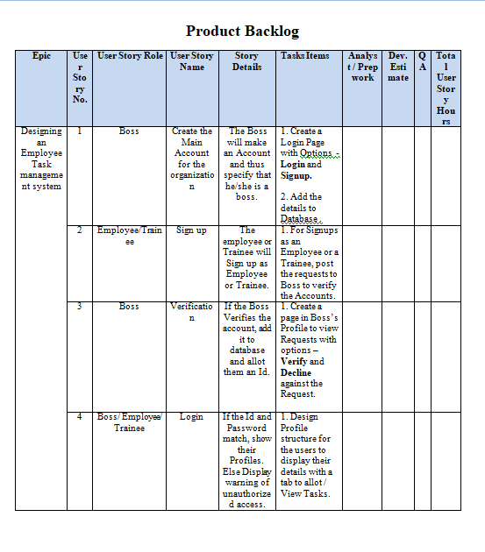

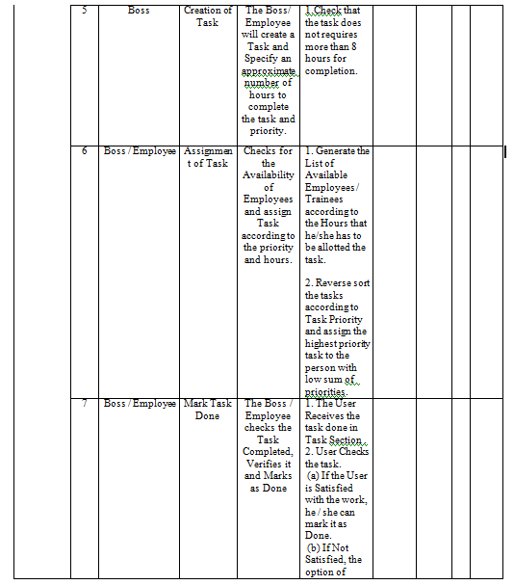

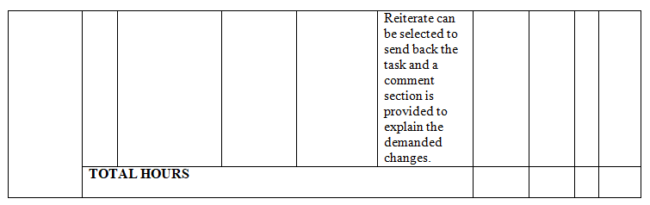

4.3. Sprint Backlogs



Sprint-backlog#1

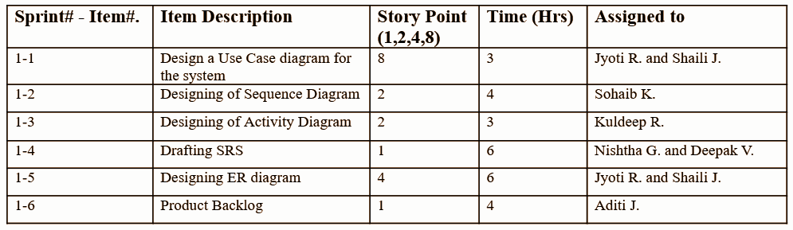

Sprint-backlog#2

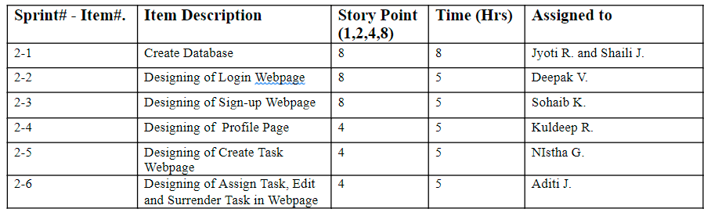

Sprint-backlog#3

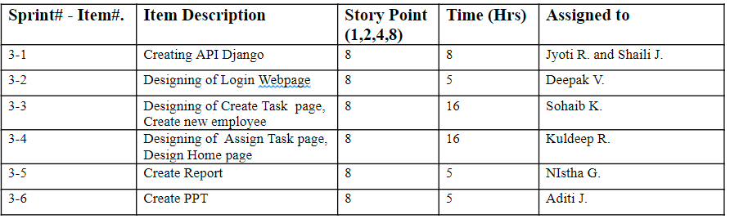

4.4. Design



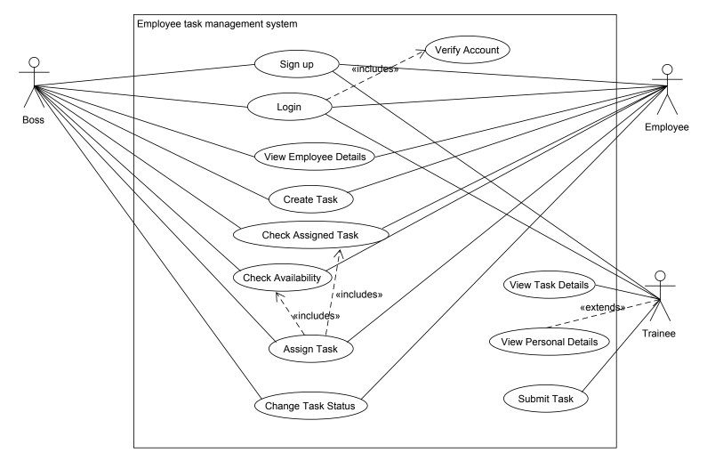

UML Diagram



Data Flow Diagram

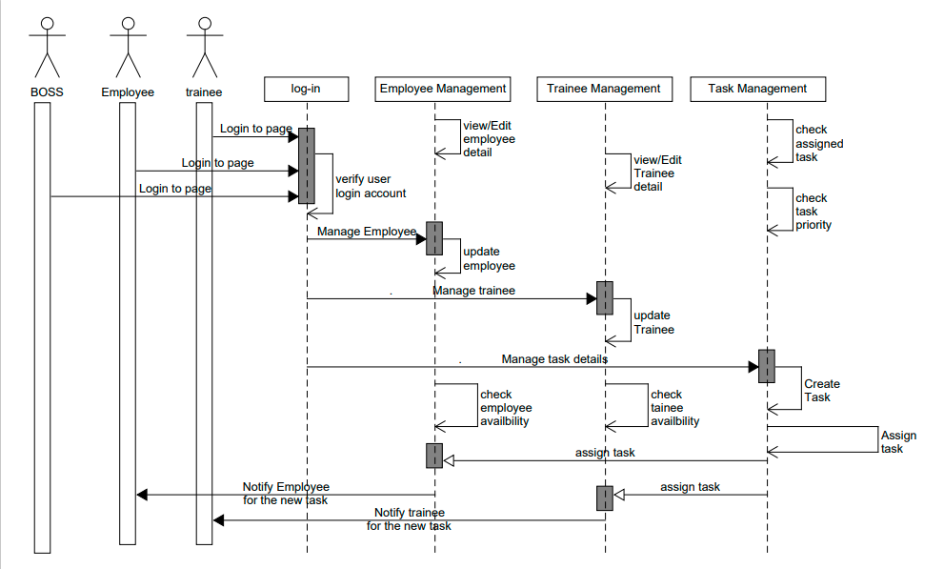

Sequence Diagram

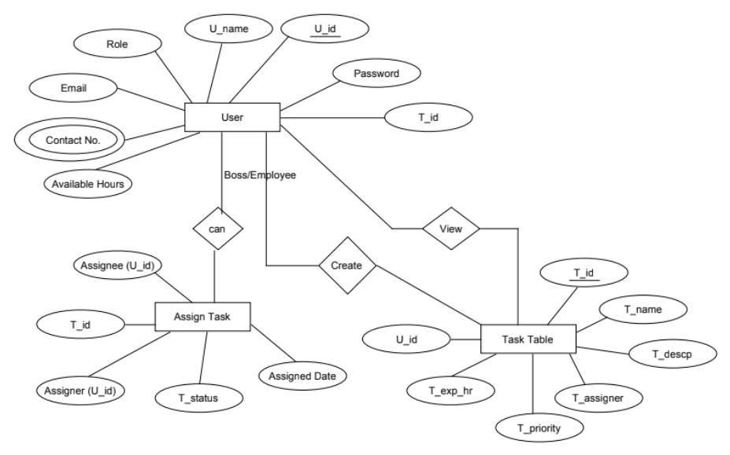

ER DIAGRAM

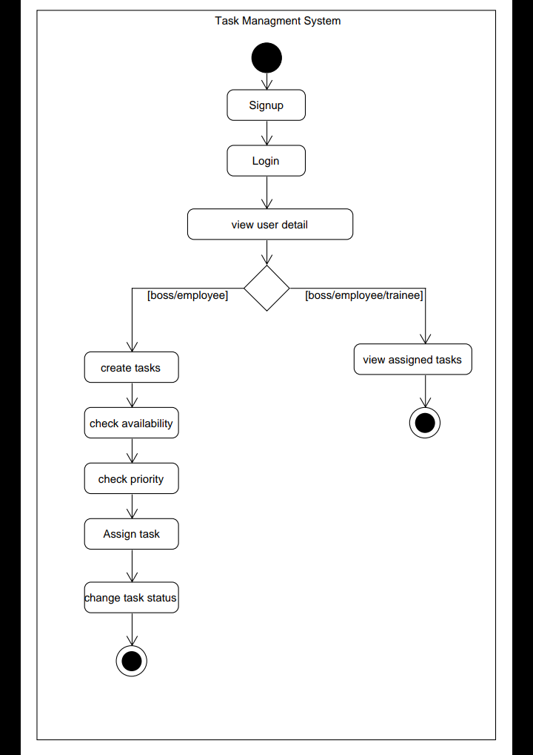

ACTIVITY DIAGRAM

4.5.Experimental Setup



In this Project we have worked on VS Code,Github.Git Bash,Mysql,Software xampp,CSS and HTML.Employee Management System is created in PHP and MYSQL. It deals with the rundown of workers in an organization or an association. It likewise contains the training went to by every Employee.

Representative is the foundation of an organization so the Employee Management System is an extremely useful framework for an association or organization. It also contains training attended by each employee. Employee is the backbone of a company so the Employee Management System is a very helpful system for an organization or company. This system also manages the company employee details like their attendance, their performance, salary details, leave details.

4.6. Results & Screenshots 

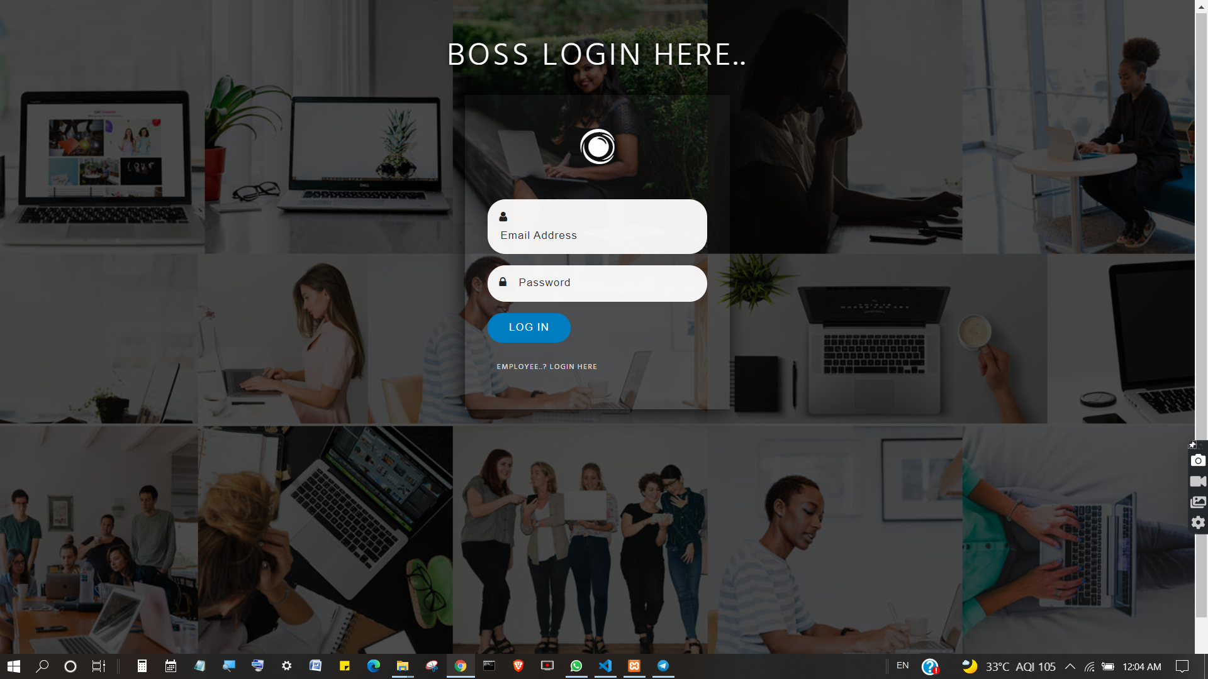

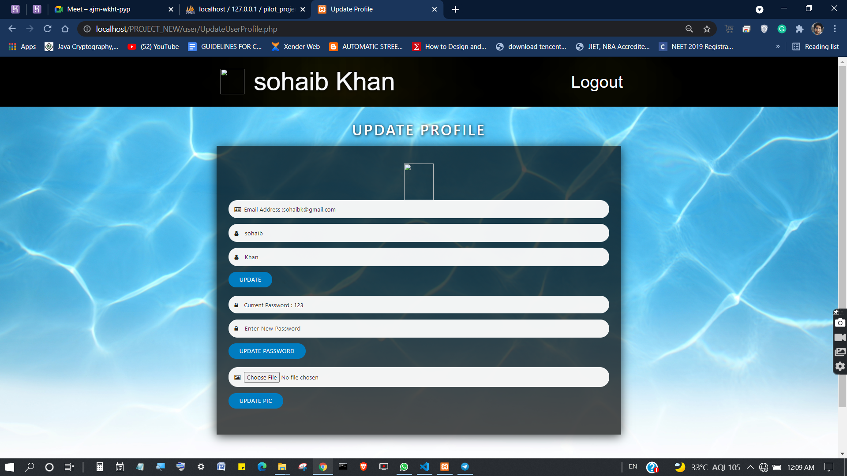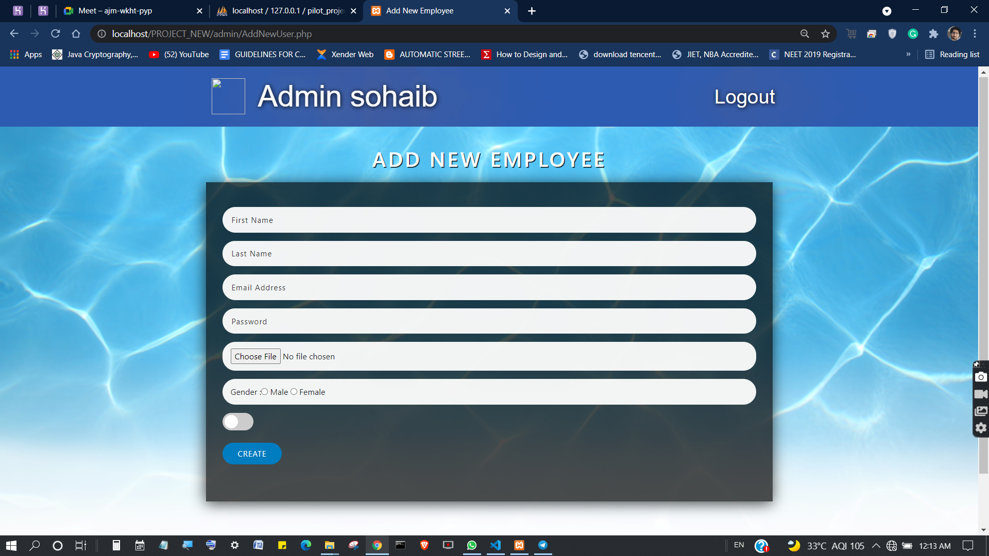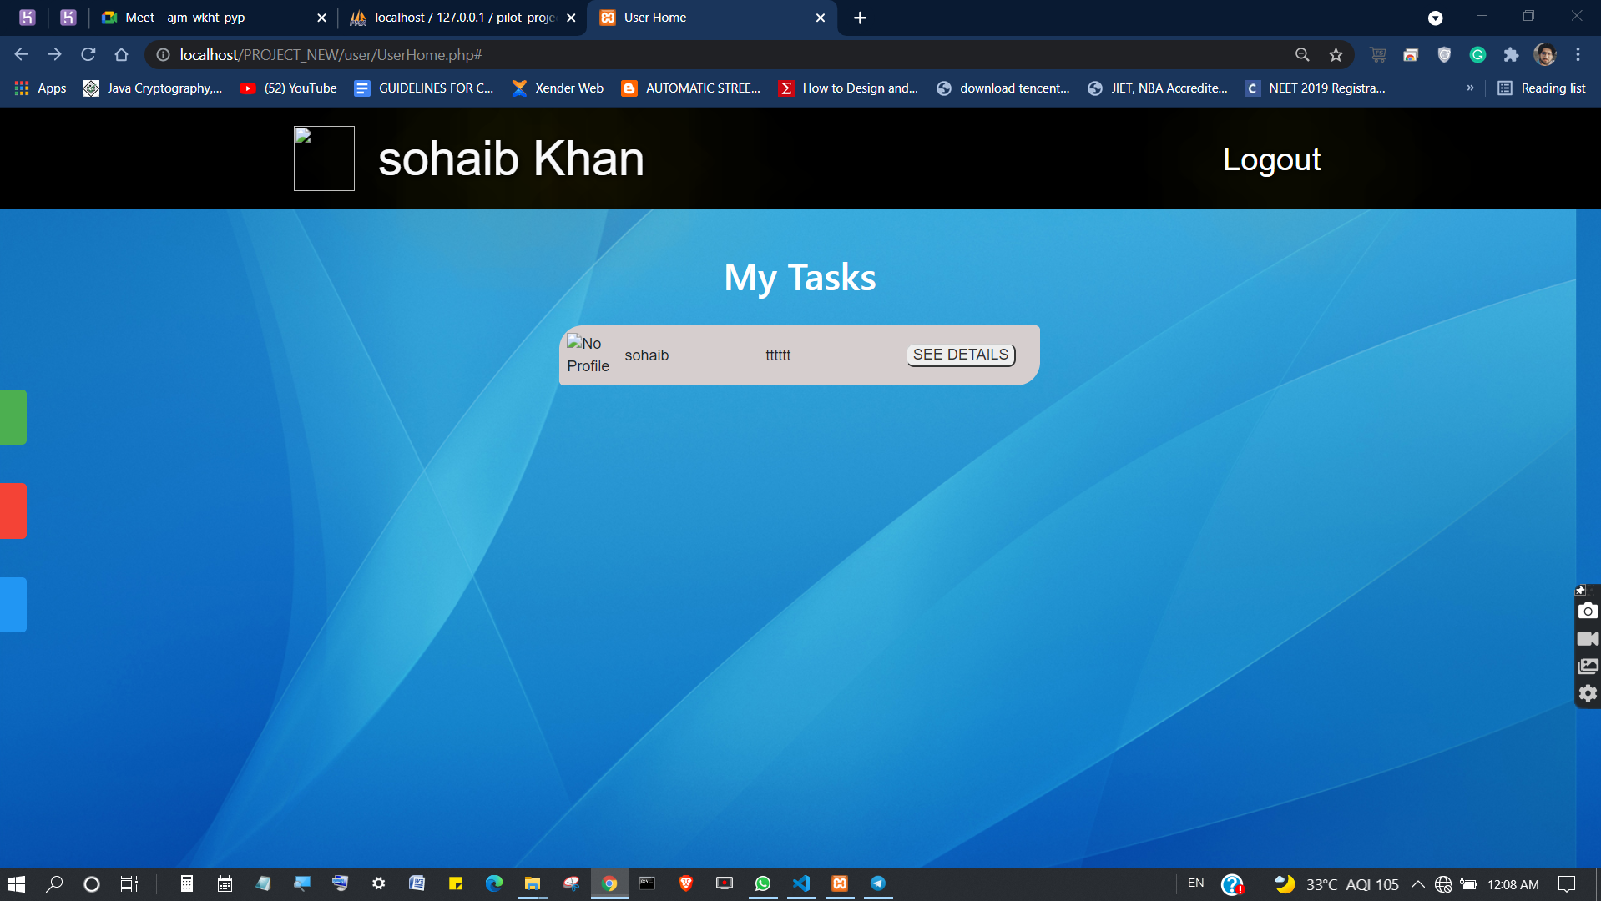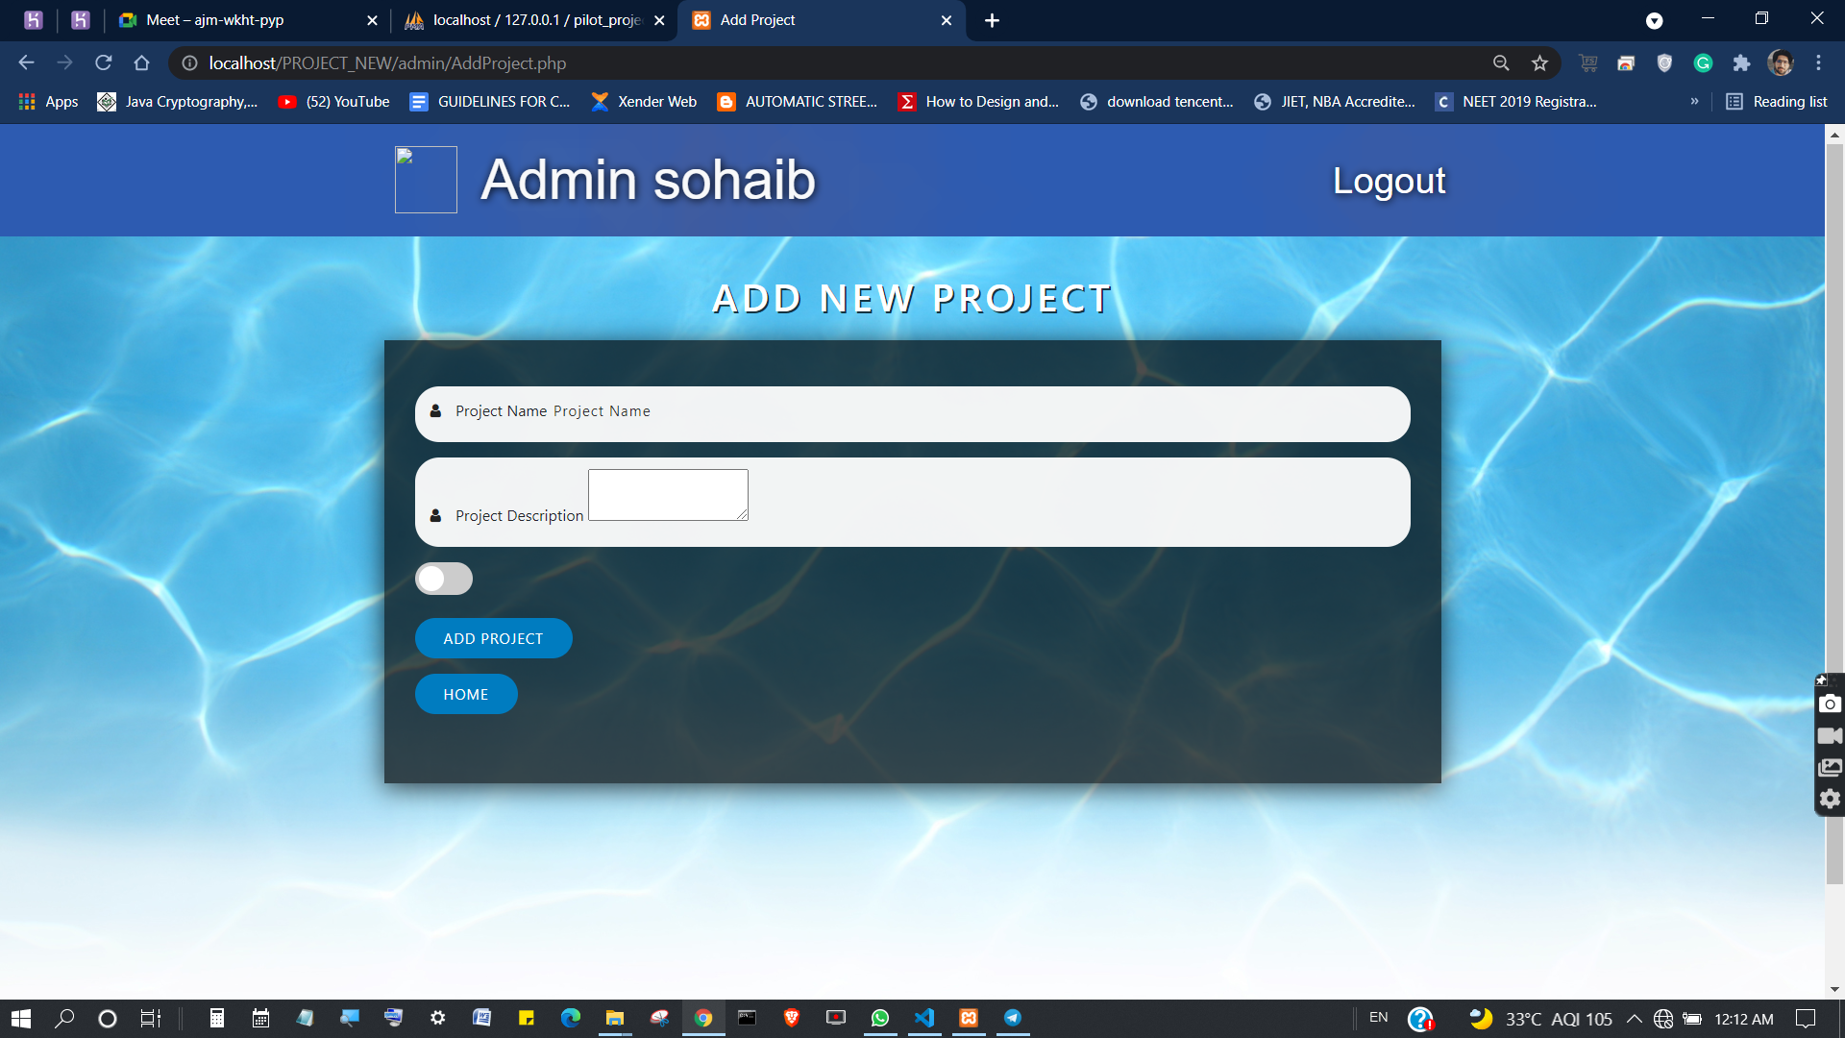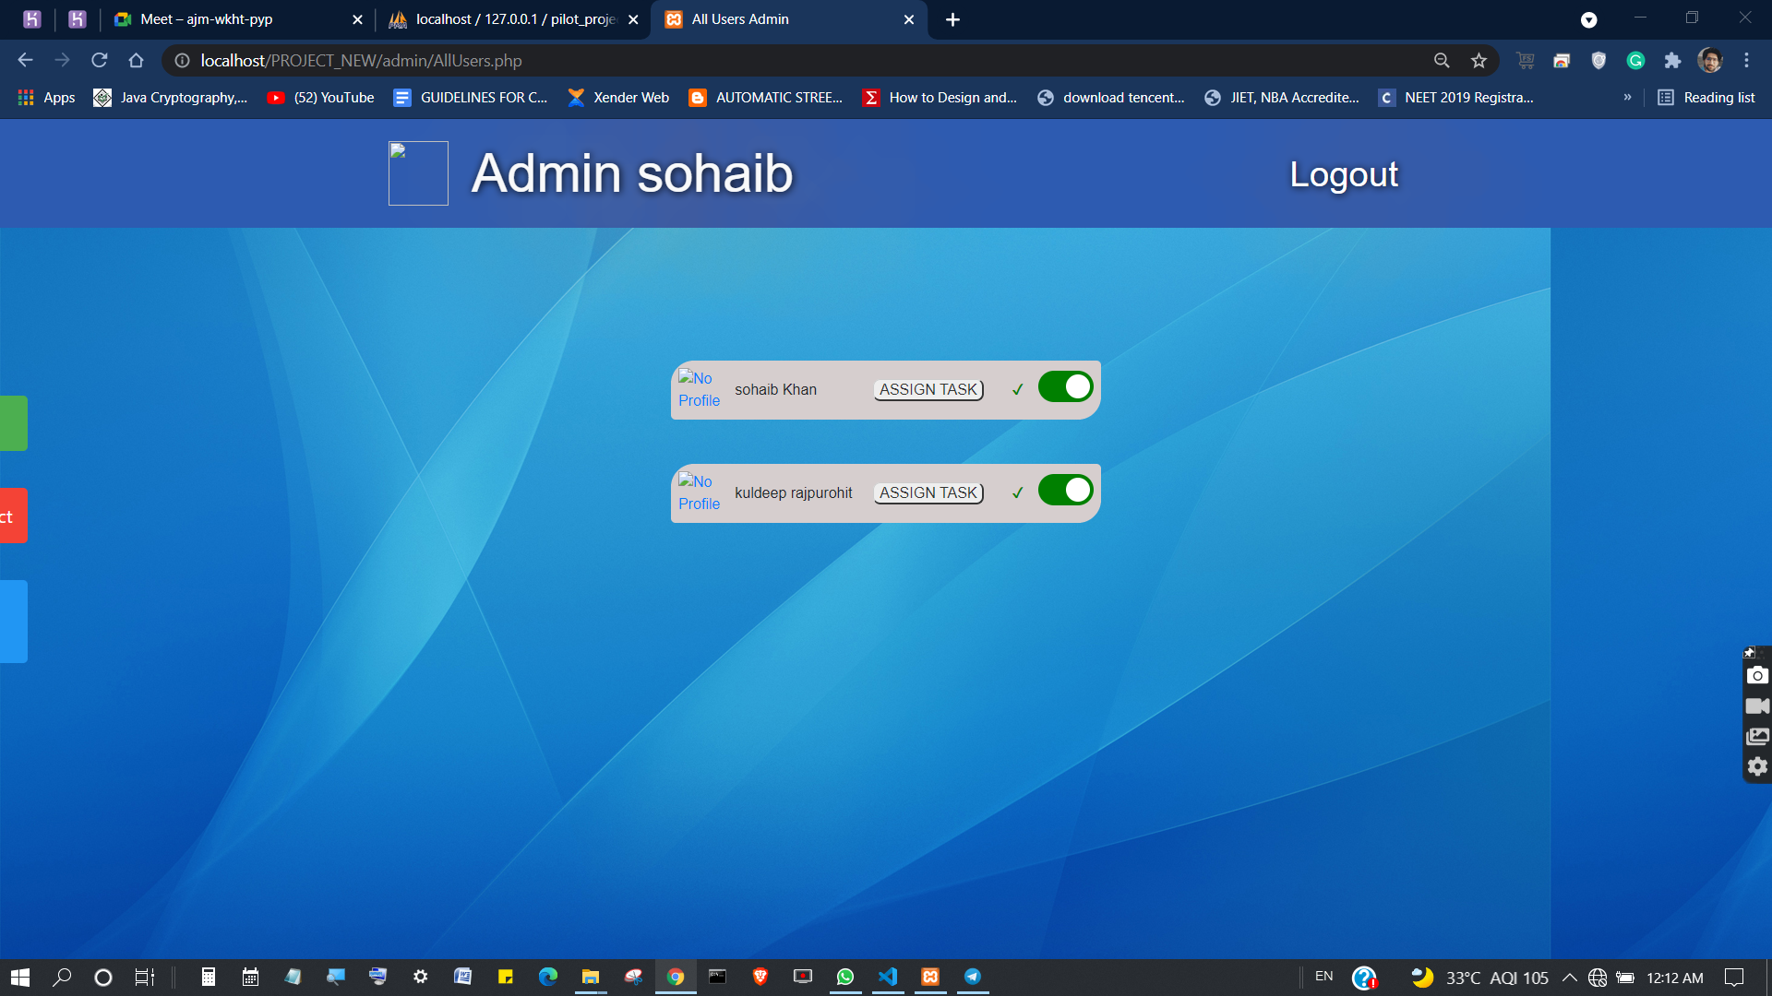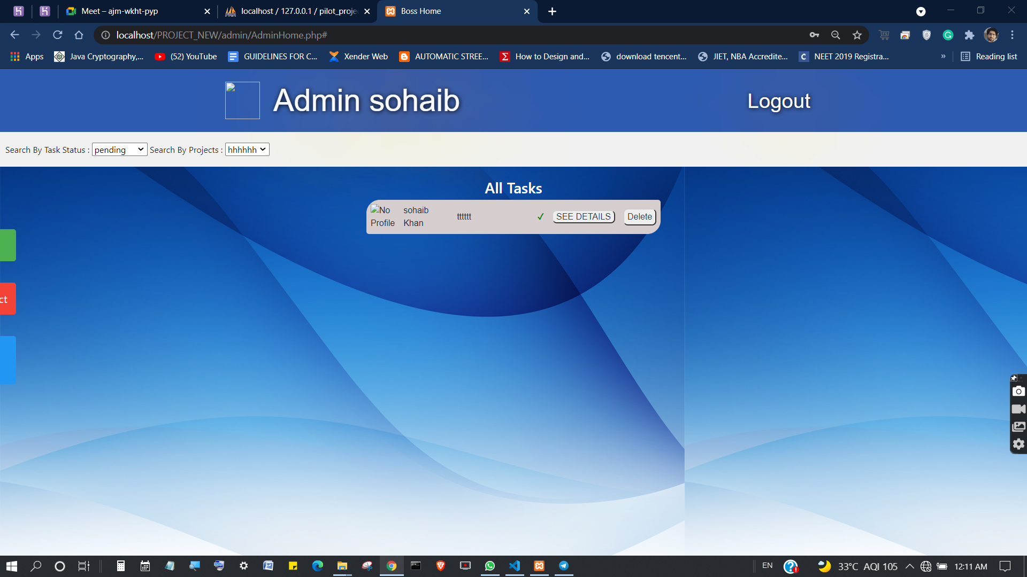

4.7. Reference / Appendix



* <https://www.geeksforgeeks.org/>
* [https://github.com](https://github.com/)
* [https://stackoverflow.com](https://stackoverflow.com/)

### 

: